SIMATS ENGINEERING

ASSESSMENT TOOL 1: Concept Mapping

COURSE NAME: | Cloud Computing and  Big Data Analytics | COURSE CODE: | CSA1504

COURSE OUTCOME COVERED
CO1: Apply cloud computing technologies including hardware-software evolution, virtualization, web services, and service models to develop cloud-based solutions. (BL2)
Assessment Tool Weightage: 20%

Dave's Taxonomy: Imitation (Level 1)  Question Count: 4 | Total Marks: 50

Code of Conduct
I S. Jefna Princy – 192572058 (Name / Reg No) certify that this submission is my original work and that I have adhered to the guidelines specified for this assessment.
I understand that any violation of academic integrity rules will result in disciplinary action. Signature of the student: Jefna princy

Assessment Tasks Concept Mapping Tasks
Create concept maps for the following tasks. Each map must show key nodes, link labels, and a logical hierarchy.
- Concept Map 1: Cloud Computing Fundamentals. Include definition, characteristics, benefits, and limitations.
- Concept Map 2: Evolution of Cloud Computing. Connect hardware evolution, internet software evolution, distributed systems, and service delivery.
- Concept Map 3: Service Models. Map IaaS, PaaS, SaaS, and XaaS with provider responsibilities and user responsibilities.
- Concept Map 4: Virtualization and Web Services as Enablers of Cloud. Show how these two concepts support cloud deployment and scalability.
Expected concept nodes:
  - Elasticity, scalability, resource pooling, on-demand access, measured service
  - Virtual machine, hypervisor, abstraction, API, SOAP, REST, provider, consumer
  - Infrastructure layer, platform layer, application layer, shared responsibility

Concept Mapping Rubric
Criteria | Weightage | Level 4 - Exemplary | Level 3 - Proficient | Level 2 - Developing | Level 1 - Beginning
Concept Identification | 25% | All major concepts are accurately identified | Most concepts are identified correctly | Limited concepts are identified | Essential concepts are missing
Relationship  Mapping | 25% | Links between  concepts are | Most links are  correct | Some links are  weak or unclear | Relationships are  mostly incorrect

accurate and
meaningful
Hierarchy and Organization | 20% | Excellent structure with clear hierarchy | Mostly organized with minor issues | Basic structure with weak hierarchy | No logical organization
Technical Relevance | 20% | Map strongly reflects cloud course content | Mostly aligned to topic | Partially aligned to topic | Weak alignment to topic
Visual Clarity | 10% | Neat, readable, and easy to interpret | Generally readable | Somewhat cluttered | Poorly presented

Permitted Tools :

draw.io / diagrams.net, Lucidchart, MindMeister, Miro, Canva, PowerPoint, Google Drawings, or equivalent diagramming tool
Procedure for Preparing the Digital Concept Map
- Use the following procedure to prepare the diagram and upload evidence.
- Students who already know another diagramming tool may use it, but the exported evidence and source file must still be submitted.
- Open https://app.diagrams.net/ or the desktop version of draw.io / diagrams.net.
- Choose Device, Google Drive, or OneDrive as the save location according to availability.
- Create a blank diagram and name the file as
CSA15_CO1_AT1_RegisterNumber_Concept_Map.drawio.
- Place the concept map title at the center or as a clearly visible anchor node.
- Add major cloud nodes: cloud definition, cloud evolution, cloud architecture, service models, deployment models, virtualization, web services, SOAP, REST, APIs, elasticity, scalability,
resource pooling, measured service, and emerging paradigms.
- Connect nodes with labeled arrows such as uses, depends on, enables, scales through, communicates through, belongs to, supports, provides, consumes, or controls.
- Use colors meaningfully: one color for service models, one for cloud characteristics, one for API/web-service concepts, and one for concept map title-specific elements.
- Export the final diagram as PNG or PDF. Keep the editable .drawio source file also.
- Paste the exported diagram image or screenshot in this DOCX under Task 1.
- Upload the DOCX, exported PNG/PDF, and .drawio file to Google Classroom.

Task 1: Concept Map
Create a concept map in draw.io, Lucidchart, Miro, Figma, or any suitable diagramming tool. The map must connect cloud ecosystem, cloud actors, service models, deployment models, virtualization, web services, REST/SOAP APIs, scalability, elasticity, and the student's Project.

Task 2A: Service Model Responsibility Matrix
Prepare a technical matrix that compares SaaS, PaaS, IaaS, FaaS/serverless, database-as-a-service, storage-as-a-service, identity-as-a-service, and monitoring/logging services. For each selected service category, explain what is managed by the cloud provider, what is managed by the student application team, and why that split fits the Project.

Task 2B: Cloud Service Decision Matrix
Map Project modules to cloud services. Include authentication, frontend hosting, backend/API layer, database, object storage, analytics/logging, notification, AI/Python module, security, CI/CD, backup, and monitoring. Students should justify the most relevant service choices instead of forcing every possible cloud service into the design.

Task 3: API Flow, Elasticity, and Scalability Design
Draw a professional cloud-flow diagram for the Project modules. The diagram must show user app or web app, API gateway/backend service, authentication, compute layer, database, object storage,

analytics/logging, monitoring, security boundaries, and scaling points. Students may replicate the given visual pattern, but all components and labels must be customized to their own architecture.

Task 4: Technical Justification
Write a concise justification explaining how the diagram and matrices prove CO1. The justification must discuss service model selection, API role, elasticity, scalability, virtualization or managed compute choice, and cloud responsibility boundaries.

1. Evaluate the effectiveness of your concept map in representing cloud computing principles. Which
design decisions most strongly support your solution, and why?
2. Analyze how scalability, elasticity, and resource management influence the architecture shown in your
concept map. What challenges could arise if these capabilities were absent?
3. Justify the selection of the APIs, web services, or cloud services included in your concept map. How do they contribute to the overall functionality and efficiency of the system?
4. Critically examine the relationships between the components in your concept map. How do these interactions improve reliability, performance, or user experience?
5. Reflect on the process of developing your concept map. How has creating and analyzing the map changed your understanding of cloud computing architecture, and what improvements would you make if you were redesigning it?

Expected Digital Evidence
  - Editable diagram source file and exported PNG/PDF for the concept map.
  - Completed service model responsibility matrix and cloud service decision matrix.
  - Architecture/API flow diagram exported as PNG/PDF.
  - README file containing title, tools used, repository structure, and a short CO1 reflection.

GitHub and Google Classroom Submission
- Create a repository using a clear name: CSA15_CO1_AT<Number>_<RegisterNumber>.
- Upload editable source files, exported PDF/PNG evidence, screenshots, and a short README explaining the work.
- Keep filenames professional and include the register number where appropriate.
- Submit only the GitHub repository link in Google Classroom before the deadline.
- Ensure the repository is accessible to the faculty evaluator during assessment.

Implementation Note
Faculty may evaluate the submitted evidence digitally using repository inspection, diagram quality, oral explanation, and CO-aligned rubric scoring. The focus is on technical understanding, cloud design reasoning, and hands-on evidence rather than routine written work.

Definition

Delivery of computing services over the internet using shared resources.

CLOUD COMPUTING

Characteristics
- On-demand
- Self-service
- Resource Pooling
- Elasticity
- Scalability
- Measured Service
- Broad Network Access

Benefits

- Cost Efficiency
- Scalability
- Flexibility
- High Availability
- Reliability
- Easy
Maintenance

Limitations

- Security Risks
- Privacy Issues
- Internet Dependency
- Vendor Lock-in
- Downtime

Cluster Computing Grid Computing Distributed Computing

Static Websites Dynamic Web Applications Web Services
REST & SOAP APIs

Mainframe Computers Client-Server Architecture Virtualization Technology
Modern Data Centers
EVOLUTION OF CLOUD COMPUTING
Hardware Evolution

- IaaS
- PaaS
- SaaS
- XaaS
Service Delivery
Distributed Systems
Internet Software Evolution

CLOUD SERVICE MODELS

IaaS (Infrastructure as a Service) PaaS (Platform as a Service) SaaS (Software as a Service)

Provides Provides Provides

Virtual Machines

Storage

Networking

Runtime Database tools

Development
Ready-to-use Software
Web-based Applications

Provider manages
Povider manages
Provider manages

Hardware Storage Networking Virtualization
Infrastructure Operating System Runtime Middleware
Infrastructure Platform Software Security Maintenance

user manages

user manages

user manages

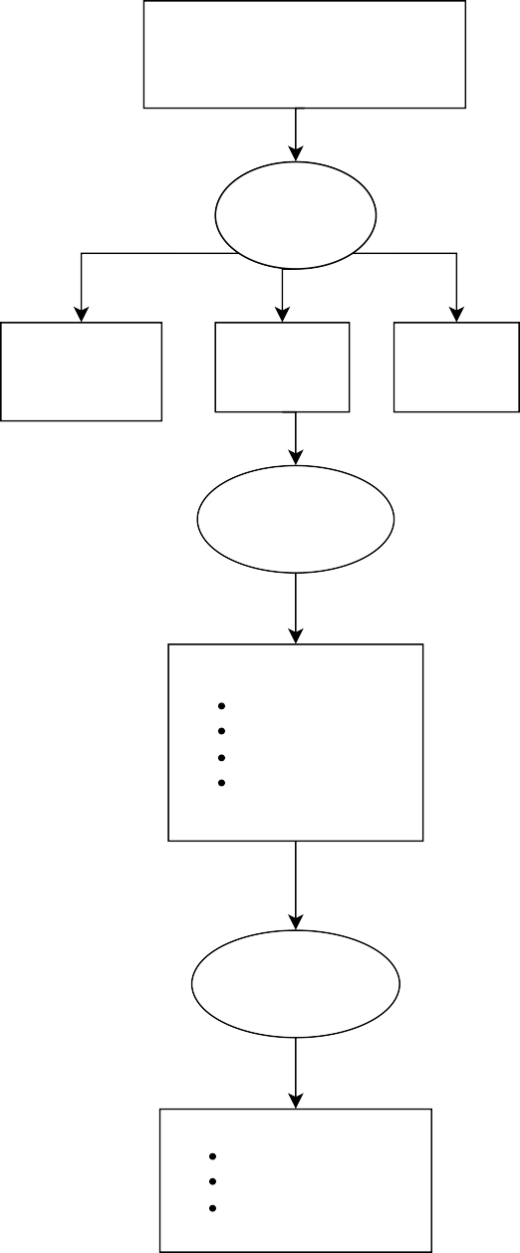
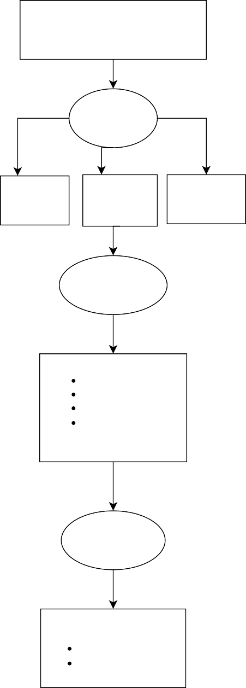
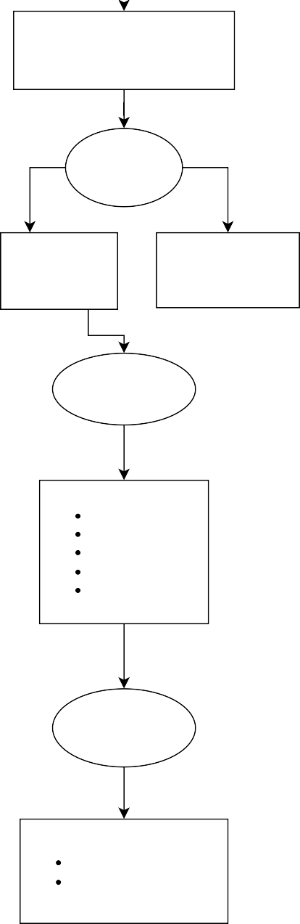
Operating System Applications
Data

Applications Data

User Data Application Settings

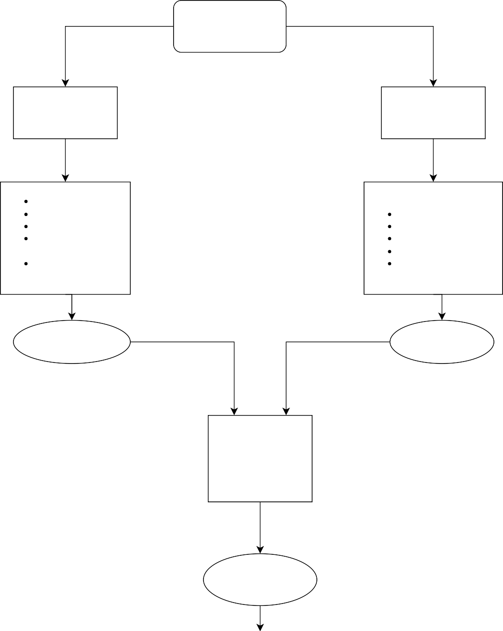
CLOUD COMPUTING
Virtualization
Web Services
Hypervisor
Virtual Machine Resource Sharing Hardware Abstraction Server Consolidation
REST API SOAP API HTTP
XML / JSON
Communication
supports
provides
Cloud Deployment

Public
- Private
- Hybrid
- Community
improves

Scalability & Elasticity Auto Scaling • Load Balancing
High Availability • On-demand Resources

